Export a Course
It’s always a good idea to export your course, saving a copy for recordkeeping purposes. Additionally, because courses only remain in Blackboard for 3 semesters after they end, you may want a backup to import later if it’s been more than 3 semesters since you taught it.

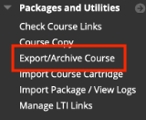
Follow the steps below to export your course.

- From within the course that you want to export, click on Packages and Utilities in the Course Management menu.
- Choose Export/Archive Course.
- On the next screen, click the Export Package button along the top gray bar.
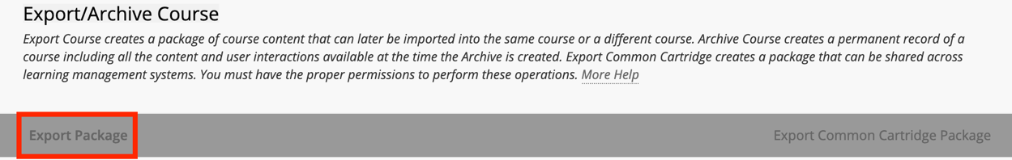
  - On the next screen, change nothing under File Attachments.
  - Scroll to the Select Course Materials section and click the Select All button.
Note: If there are discussion forums in the course, switch the radio button to “Include only the forums, with no starter posts” (just like a course copy).
  - Click Submit, which will take you back to the Export/Archive screen.
- A purple Success banner will appear across the top, indicating the action has been queued and that an email will be sent (to your DMACC email) when it is complete.
- Keep open the Export/Archive screen or return to it once you receive the email (generally within minutes), and then click on the Refresh button.
- A .zip file will appear below—right-click the file name and choose “Save Link As…” (“Download Linked File As…” in Safari) to download and choose where to save the file. Recommended: your local computer or P drive.
  - Do NOT attempt to open or unzip it; only Blackboard can read this file.
- You have now exported and saved a copy of your course.
Need Help?
If you need help with this process or with importing an exported course, please contact one of our instructional designers.

